Cohort Retention Analysis – Alpha Manufacturing Solutions
Meridian People Analytics Consulting

Employee Cohort Retention Curve
The overall cohort retention curve illustrates the probability that an employee remains with the organization as their tenure increases. At the start of employment (year 0–2), retention remains extremely high at approximately 1.0000 (100%). This indicates that nearly all employees remain with the company during their early years of employment.
However, retention begins to decline significantly after year 2. By year 3, retention falls to approximately 0.8600 (86%), suggesting that the first notable wave of attrition begins once employees have gained initial experience and marketable skills.
The most dramatic decline occurs between years 4 and 5. Retention drops from approximately 0.7200 (72%) at year 4 to 0.5000 (50%) by year 5. This means that half of the original employee cohort has left the company within five years of joining.
After year 6, retention stabilizes at approximately 0.4200 (42%), indicating that employees who remain beyond this point are significantly more likely to stay long term. From a strategic workforce perspective, the most critical retention window for the organization is between years 3 and 5, where the majority of attrition occurs.
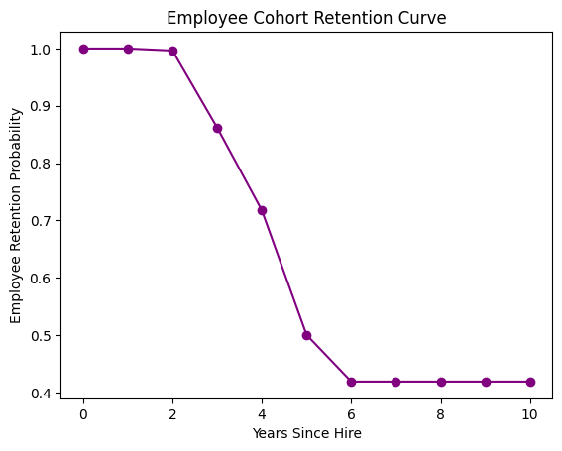

Cohort Retention Curve by Promotion Status
When retention curves are segmented by promotion status, a significant difference emerges between employees who received promotions and those who did not.
Employees without promotions experience steep attrition over time. Retention for this group drops from nearly 1.0000 in the first two years to approximately 0.8600 by year 3 and 0.7100 by year 4. By year 5, retention declines to approximately 0.4900 (49%), meaning more than half of the employees in this group have left the organization.
In contrast, employees who received promotions demonstrate significantly stronger retention. Retention remains above 0.9400 (94%) at year 3 and approximately 0.9100 (91%) through years 5–10. This suggests that promotions dramatically improve employee commitment and reduce turnover.
The difference between these two curves highlights one of the most powerful drivers of retention: career advancement. Employees who receive promotions are nearly twice as likely to remain with the organization after five years compared to employees who do not receive advancement opportunities.
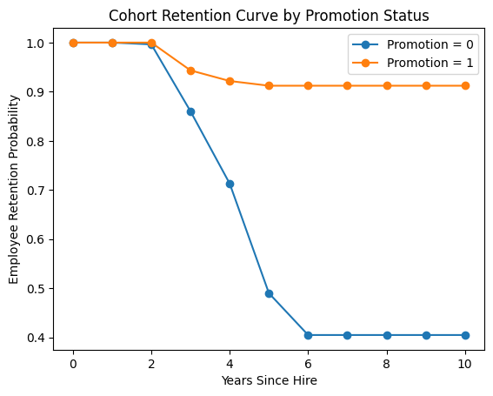

Employee Retention Curve by Satisfaction Cohort
The satisfaction cohort analysis segments employees into three groups: Low Satisfaction (0.0–0.3), Moderate Satisfaction (0.3–0.6), and High Satisfaction (0.6–1.0). The retention curves reveal meaningful differences in how satisfaction levels influence employee retention.
Employees with low satisfaction levels experience the fastest attrition. Retention for this group falls rapidly after year 3, dropping to approximately 0.5000 (50%) by year 4 and stabilizing around 0.4000 (40%) thereafter.
Moderately satisfied employees show more stable retention patterns. Retention declines to approximately 0.5900 (59%) at year 3 and stabilizes around 0.5000 (50%) after year 6. While attrition still occurs, it happens at a slower rate compared to the low satisfaction cohort.
Employees with high satisfaction initially demonstrate extremely strong retention, remaining near 0.9800 (98%) through year 4. However, a noticeable drop occurs between years 4 and 6, where retention falls to approximately 0.4300 (43%).
Overall, the analysis confirms that employee satisfaction plays a major role in workforce stability. Employees with lower satisfaction levels are significantly more likely to leave the organization earlier in their tenure, highlighting the importance of engagement initiatives, strong management practices, and workplace culture improvements.
